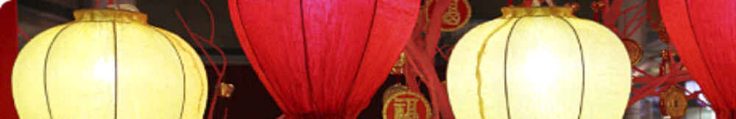

Gong Hey Fat Choy! ????!
2020 Chinese New Year Banquet & Special Program

Date & Time: Thursday, January 30, 2020, 6:30 p.m. Registration begins at 6 p.m.

Venue: Maple Garden, 909 Isenberg Street. Tel: 941-6641.

Parking: Restaurant parking lot, or First Hawaiian Bank. Bank closes at 4 pm on Thursdays.

Cost: $60 per person ($25 tax deductible). Please fill out the form at the bottom and mail it with your check, payable to SAAH. Scholarship students free.

Deadline: January 27, 2020. Free seating. Max 60 persons. BYOB!

The Menu: 1) Dry Scallop Fish Maw Soup; 2) 4-Cup Chicken; 3) Steamed Garlic Shrimp with Luk Fen; 4) Smoky Tea Duck; 5) Taro Pork Belly; 6) Steamed Whole Seasonal Fish; 7) Chive Flower with Shredded Pork and Dry Tofu; 8) Stir- fried Garlic Snow Pea leaves; 9) Desserts.
Vegetarians/Vegans: Please contact Vice President Roberta Sullivan (C: 561-5882)

Guest speaker: Dr. Kate Lingley, Associate Professor of Art History; Chair of Department of Art and Art History, UH M?noa 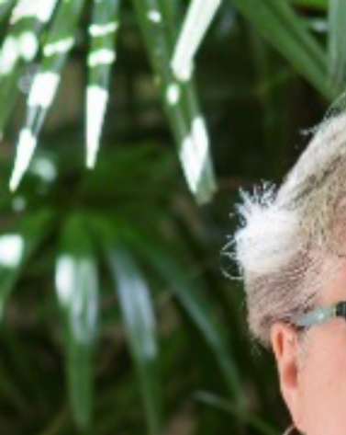

Topic: Ruins, Traces, and Pathways: Contemporary Art and the Chinese City

One of the defining experiences of contemporary life in Sinophone East Asia has been rapid urbanization, most dramatically in the People’s Republic of China, but also in Taiwan, Hong Kong, Macau, and Singapore. While the premodern Chinese painting tradition, in foregrounding landscape painting above other subjects, has focused on remote mountain landscapes and unspoiled wildernesses, these spaces are rapidly disappearing from many parts of the Chinese cultural sphere today, thanks to the growth of cities and industrial landscapes. As a result, contemporary artists’ response to urbanization has become a major theme in the contemporary art of the region. This talk will explore some of the ways in which contemporary artists in Chinese cities have used their work to respond to the changing social, aesthetic, political, and physical environment they occupy, with special attention to Beijing and Hong Kong.

Professor Kate A. Lingley has a B.A. from Harvard-Radcliffe College, M.A. and Ph.D. from the University of Chicago. Her research focuses on Buddhist votive sculpture of the Northern and Southern Dynasties period, with a particular interest in the social history of religious art in medieval China. Her articles in this area have been published in Asia Major, Ars Orientalis, Early Medieval China, and Archives of Asian Art, among others. A book project related to her research interest is underway.

Early Bird catches the worm! See you there!

Please cut along the dotted line, fill out and mail it with your check to:
Carolyn Haik, 1189 Waimanu St, #2804, HNL 96814.
……………………………………………………………………………………….

Yes, I/we will attend. Name(s): ______________________________I have __________ guests. Tel: _____________________.

_____Enclosed is my personal check at the amount of ___________.

_____I will pay at the door. Please sign me up now.

